Software Requirement Specification

*SwissHomes*

**ESE Team 1**

Alain Brunner

Gretar Geiser

Janik Endtner

Marcel Sidler

University of Bern

08/10/2016

Contents

1 Introduction 4

1.1 Purpose 4

1.2 Stakeholders 4

1.3 Scope 4

1.4 Definitions 4

References 4

2 Overall description 5

2.1 Product Perspective 5

2.2 Use Cases 5

2.2.1 Sign up and Login/Logout 5

2.2.2 Advertising 5

2.2.3 Ad search 5

2.2.4 Message 6

2.2.5 Enquiries 6

2.2.6 Ad alerts 7

2.2.7 Buy and Sell 7

2.2.8 Auction 7

2.2.9 Premium User 7

2.2.10 Google Login 8

2.2.11 Home Page 8

2.2.12 Update Profile 8

2.2.13 Google Maps to show location of ads 9

2.3 GUI 9

2.4 Patch History 9

2.4.1 Task 1 9

2.4.2 Task 2 9

2.4.3 Task 3 10

2.4.4 Task 4 10

2.4.5 Task 5 11

2.4.6 Tasks 6 & 7 12

2.4.7 Tasks 8 & 9 12

3 Specific Requirements 13

# 1 Introduction

## 1.1 Purpose

This document was created for the developer of the website, as well as for every other member of the ESE 2016 Team 1 group which are in relation to this project. It is also thought to inform the customer, every tester and potential user (that is, every stakeholder) of the website.

## 1.2 Stakeholders

Manuel Leuenberger (part of the ESE 2016 staff) as customer.

The development team, the ESE 2016 Team 1.

## 1.3 Scope

SwissHomes is a website on which rooms, studios, houses and flats can be put to be sold directly, per auction or to be rented. Users can search for objects within preferred locations and it is also possible to contact the owner with SwissHomes to pose questions or arrange visits. Originally called FlatFindr, the project was edited by the ESE 2016 Team 1 from the University of Bern and later renamed to SwissHomes. The website is not a new project, the ESE 2016 Team 1 simply received the task to expand it.

## 1.4 Definitions

Ad Short for advertisement. An advertisement is, in this case, an offer of a property (which can be of the type house, flat, room or studio), placed by a website-user. Other users can visit those ads and interactively acquire the offered properties.

SRS Short for “Software Requirements Specification”. It is the description of the software system while it was in development and after completion as well and represented with this document.

User If it says user, it is actually website-user, i.e. user of the website SwissHomes.

## References

Look at System_as_is.md for further graphical information about use cases.

# 2 Overall description

## 2.1 Product Perspective

SwissHomes is a modification of the Flatfindr-webpage, which was provided by the ESE staff. The ESE 2016 Team 1 then modified the Flatfindr-webapplication until it contained numerous features, listed under 2.2 Use Cases.

## 2.2 Use Cases

### 2.2.1 Sign up and Login/Logout

A new user has to sign up first. For that, he needs to specify his first and last name, an e-mail address as well as a password for his account.

Once created, the account is always accessible via login-function with e-mail and password (since every e-mail address is unique). (as shown below)

When logged in, there is always the option to log out again.

There are also several accounts provided to log in as a guest. These profiles are public, that is, accessible by every user of the page.

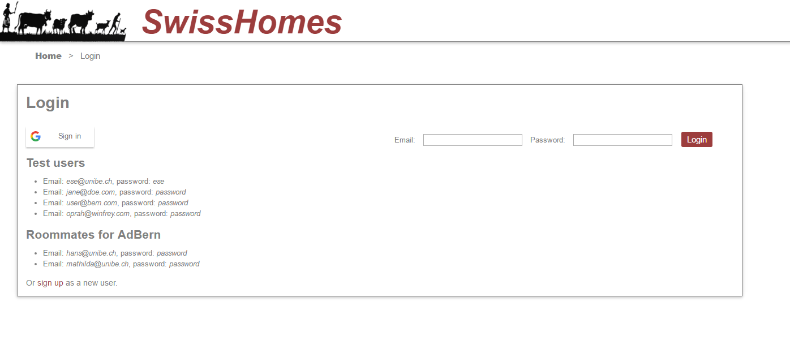

Figure 1: Login page

### 2.2.2 Advertising

A user can create a new advertisement for a property he either wants to sell, rent or auction off to someone. To do so, he only needs to provide enough information about the property (e.g. location, type, size), and then place it.

### 2.2.3 Ad search

The website can be used to search for placed ads. The search provides a filter to specify the user’s interests. Interesting ads can be bookmarked. (as shown below)

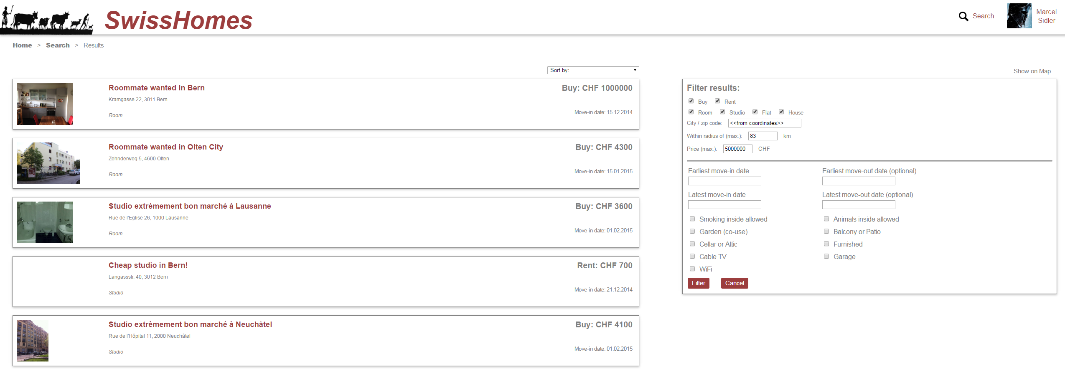

Figure 2: Search results, filter on the right

### 2.2.4 Message

A user has the ability to send and receive messages to other users of the site directly on the webpage. Receiving messages are stored in order, so they can be read chronologically. There is also the possibility to respond directly with an answer-message.

This message service not only receives manually written ones by other users, but also automatically generated ones. Messages are sent to the user whose…

* …alert triggers.
* …account was created.
* …auction gets bought out.
* …auction gets a new highest bid.
* …auction ends.

Additionally, messages are sent to users who…

* …buy-out an auction.
* …win an auction with the highest bid when it ends.
* …lead an auction with the highest bid, but then the auction gets bought out.
* …lead an auction with the highest bid, but then she/he gets overbid.

All of these messages also generate an e-mail to the user’s e-mail-address, except when an alert triggers only premium-members will get an e-mail (2.2.9 Premium user).

### 2.2.5 Enquiries

If there is an ad you really like and want to see the place in real life, you can send an enquiry to its owner directly through the ad. These visiting times are predefined by the creator of the ad. By clicking on one of the enquiries, a request is sent to the property owner. The owner then can accept or reject the user’s enquiry.

### 2.2.6 Ad alerts

A user can create an ad alert, which will tell her/him when someone put up an ad that fulfills the previously defined criteria. Once an alert gets triggered, the creator of the alert will receive a message (2.2.4 Message). This message will also be received as an e-mail, as long as the user is a premium-member (2.2.9 Premium user).

### 2.2.7 Buy and Sell

A user has not just the ability to rent properties, but also to buy and sell them. He can sell with placing an ad (2.2.2 Advertising) and buy or rent with searching for properties (2.2.3 Ad search) and then, after clicking on one, hit the buy-button.

### 2.2.8 Auction

A user can also offer her/his property as an auction, so other users can bid on it. When placing an ad (2.2.2 Advertising), the user needs to choose “Auction”. After a certain amount of time, the auction will be finished and the highest bidder will become the buyer. However, if there is a bid within the last 15 minutes of the auction, the end of auction will be extended by another 15 minutes. So, let us say, the initial end of auction time was 8.00pm and there is a bid at 7.55pm, the new time at which the auction ends will be 8.15pm. Auctions will generate many messages (more information at 2.2.4 Message). It is necessary for a user to be logged in to be able to bid. (as shown below)

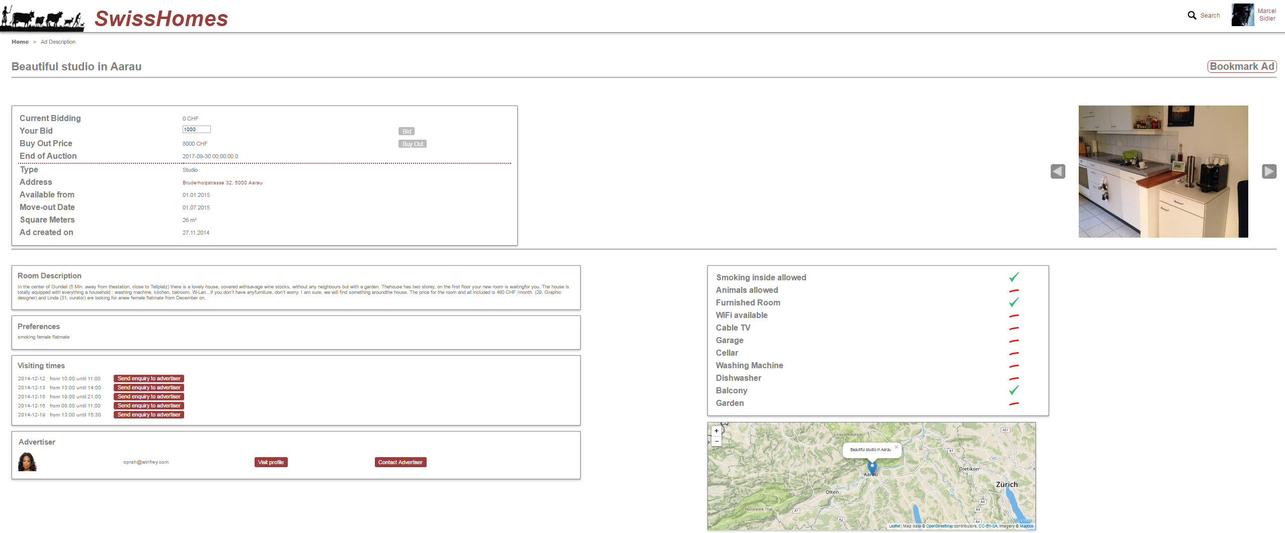

Figure 3: Layout of an auction ad

### 2.2.9 Premium User

A normal user has the ability to buy premium-membership with real money (in this case it is simulated). For that, he needs to state his credit card details. When successfully attaining premium-membership, a user has the following benefits:

* The placed ads of premium users appear higher in the search than those of normal users.
* The messages from triggered alerts will show up earlier than those of normal users.
* Alert messages will also automatically be sent to the premium user’s e-mail.

### 2.2.10 Google Login

Instead of creating a new account or using a provided one, it is also possible to use an existing Google-account to log in to the webpage. The user only needs to click on the Google-sign-in-button in the login screen and then proceed log in to his Google-account. After successfully doing these steps, the profile name will be overtaken from the Google-account, as well as the profile picture and other user data like gender, e-mail-address, … (as seen in figure 1 under 2.2.1 Sign up and Login/Logout)

### 2.2.11 Home Page

The previously called FlatFindr was renamed to SwissHomes by the ESE 2016 Team 1. The home page received a major rework. The dominant object on the home page is now an implemented map from Google-Maps, zoomed in to Switzerland. The mouse-cursor is encircled by a yellow ring. When clicking on the map, it will automatically initialize a search for properties within the area of the yellow circle. The circle does not scale with zooming in and out on the map. This makes it possible to search in whole Switzerland as well as only in Bern. Every kind of ad will show up as a result. (as shown below)

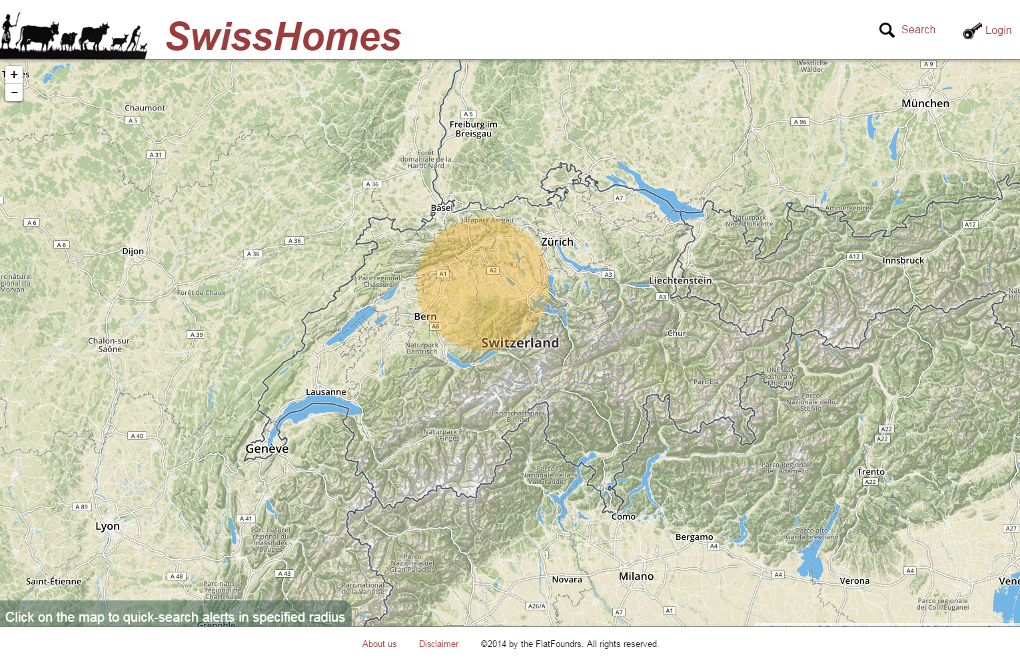

Figure 4: Home page

### 2.2.12 Update Profile

It is possible to update a profile, that is, to change the name and the e-mail-address. However, a user will get logged out when changing the e-mail-address. This is not the case when only changing the username. Other things that can be changed without getting logged out are:

* First name
* Last name
* About me
* Password

### 2.2.13 Google Maps to show location of ads

In the ads, there is a framed piece of Google Maps implemented so that the location of the property is quickly visible. The location is marked on the map. When opening Google Maps through this implementation, the marker will stay as an orientation object.

## 2.3 GUI

There are no key-shortcuts implemented in the project. A user operates on the website with mouse only. The layout is similar to most of the popular websites on the internet, so every user will manage to orient himself easily on the page.

## 2.4 Patch History

In the following, there is defined the task and its implementation for each week of development.

### 2.4.1 Task 1

So far it was only possible to filter the results after initially starting a search first. The task was to make it possible to filter the results from the beginning.

Implementation (Date: 10/18/2016-10/21/2016):

-Search function now has a filter from the first use on.

-Bug fix within search function.

-Bug fix for new accounts. Message box no longer results in an error.

### 2.4.2 Task 2

The three goals of this task were:

* Received personal news on the website should trigger a further message to the mail address of the user.
* Additionally to rooms and studios it should also be possible to offer flats and houses.
* Expand the offer-types with “sell” and “auction”. Only concept of auction required for next week.

Implementation (Date: 10/25/2016-10/26/2016):

-Auction is a new checkbox option when editing and placing an ad.

-Buy-out button available.

-Flats and houses as property types added.

-Minor text fixes.

-Received messages on the website are sent to the user’s e-mail address as well.

### 2.4.3 Task 3

* It should be possible to search for rooms, studios, flats and houses with the filter.
* The search function should only show up-to-date properties (depending on the move-in-, move-out- and end-of-aution-dates).
* Creating an auction should include:
* Minimal price
* End of auction (date)
* Buy-out-price (if wanted)
* Every user should be able to create an auction (and edit it afterwards). Other users should be able to bid on auctions with at least 105% of the previous bid. If someone makes a bid within the last 15 minutes before auction ending, it should be added another 15 minutes to the end of auction time. After auction ending or if someone bought it out, the auction should not be buyable anymore.
* The creator of the auction should get messages when...
  + …there is a new bid.
  + …the auction gets bought out.
  + …the auction ends.
* The bidder of an auction should get messages when…
  + …she/he successfully buys it.
  + …she/he gets overbid.
  + …the auction ends.

Implementation (Date: 10/28/2016-11/02/2016):

-Bug fix within search function.

-Search function modified to handle the additional property types.

-Bug fix concerning the place-ad-function.

-Auction partially implemented (creation and bidding works).

### 2.4.4 Task 4

The main task was to complete the implementation of the auction (details at task 3). Also, there are several problems to be fixed:

* Bidding should not happen on a new tab in the browser.
* It should not be possible anymore to underbid on an auction.
* The next possible bidding should be 105% of the previous bidding.
* It should not be possible to bid if not logged in as a user.
* The interface of placing an ad should be updated such as to choose auctions.

Following problems occurred concerning the alerts:

* Alerts only work with rooms and studios.
* Alerts should use the same filter as the search function.
* Already created alerts should be editable.

Implementation (Date: 11/03/2016-11/07/2016):

-Text- and bug fix in alerts.

-Possible to place ads as auctions.

-Ad’s interfaces updated to auction-handling.

-Auction ends when bidding reaches the buy-out-price.

-Search filter in alerts.

-Now sending messages when actions on auctions take place.

-Minor implementations and bug fixes.

-New alert algorithm.

-End of auction converted to hours and seconds.

-Not all ads are displayed in MyRooms anymore.

-Auction’s ends extend when late bids are made.

### 2.4.5 Task 5

The task of this week were mainly improvements to the existing code:

* It should be sent a message to a user when he gets overbid on an auction.
* The price of a property should be more dominant in the ad, especially at auctions.
* The search should only result in active auctions.

Implementation 5 (Date: 11/09/2016-11/13/2016):

-Message when overbid.

-Bug fixes within editing an ad.

-Bug fixes within alerts.

-Bug fixes within placing an ad.

-Layout improvement of ads, especially auctions.

-Inactive/ended auctions will no longer appear in search results.

-Implemented Google-Maps on every ad to show the location.

### 2.4.6 Tasks 6 & 7

The task was to improve the overall design of the page. It should have its own style, something special to define this website. Additionally, users should have the option to buy premium-membership (simulated).

Implementations (Date: 11/17/2016-11/30/2016):

-Google Maps on home page, to directly search for properties within a given radius.

-Users can now update their profile.

-Users can provide their credit card data to gain premium-membership with benefits.

-Message sent when an auction ends.

### 2.4.7 Tasks 8 & 9

The last big task was to implement a Google-login-option. A user should be able to log in with his Google account, instead of making a new or using a public one.

Implementations (Date: 12/04/2016-12/14/2016):

-Google login now works. Data (e.g. username, profile picture) is adopted to the webpage.

# 3 Specific Requirements

The website should be accessible from any web browser.

The following data will be secured if someone enters the webpage:

IP-address, date, time, browser request, information about the browser as well as the system software. This is for security reasons. Users are protected under the copy right and the privacy protection law.